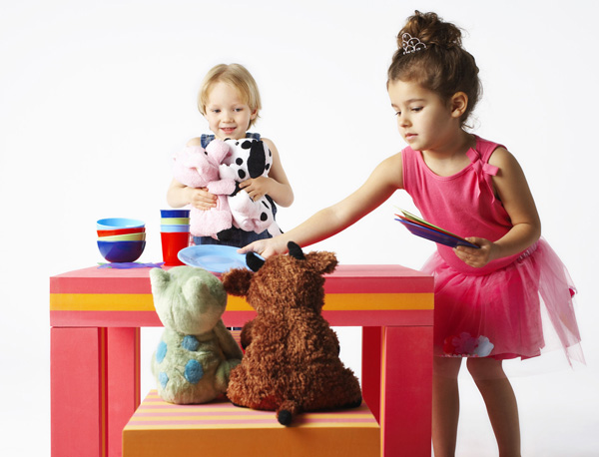

**Boston Bar**

**Elementary Secondary School**

*This Handbook belongs to:*

*_*

**Student & Parent Handbook**

2020-2021

Boston Bar Elementary Secondary

## tips for parents

**Respectful and Responsible:**

* Treat your child with respect. This will help them become more aware of their worth and in turn be more considerate of others.
* Establish clear and consistent limits. They will know what is expected of them and find is easier to be responsible for their own behavior.
* Express your disapproval towards your child’s undesirable behavior without referring to his character. Address the behavior and choices as bad as opposed to your child.

**Use your Head:**

* Set realistic disciplinary requirements for your child. Expectations that are too high induce failure and a loss of self-worth.
* Help your child to realize that no one is perfect. Teach them to learn from and fix mistakes and then move on.

**Listen and Learn:**

* Encourage your child to talk to you and really listen to them. Self-expression and communication are important life skills.
* Listen to your child and if they don’t talk, ask questions. Showing interest in their d ay, their goals and their feelings will encourage positive communication and bonding between you and your child.

**Enjoy and Let Others Enjoy:**

* Encourage your child to take part in activities where they can succeed. The satisfaction they feel with success will help them to build self-confidence.
* Measure your child’s achievements in terms of their own record not in comparison to older brothers, sisters or friends.
* Celebrate your child’s achievement and successes. Even the smallest of the small ones.

**Remember, it takes a village to raise a child, we want and welcome your involvement in your child’s education.**

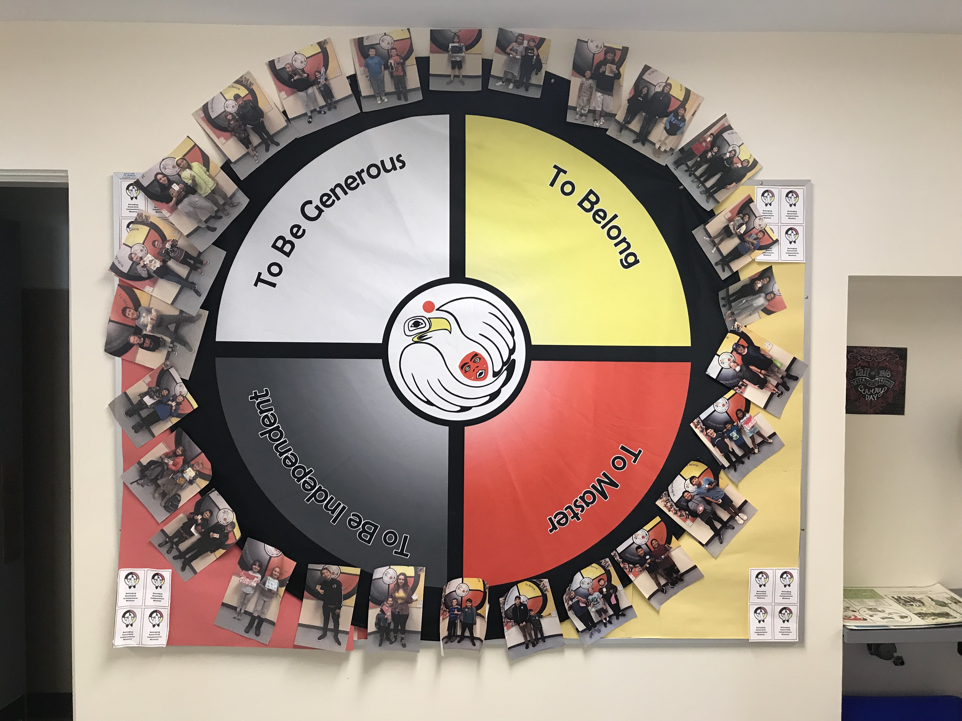

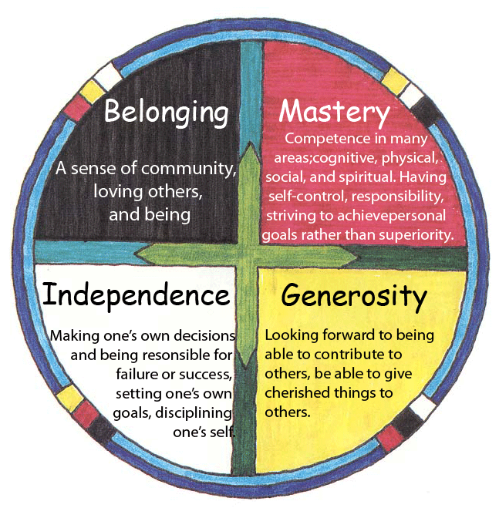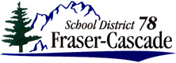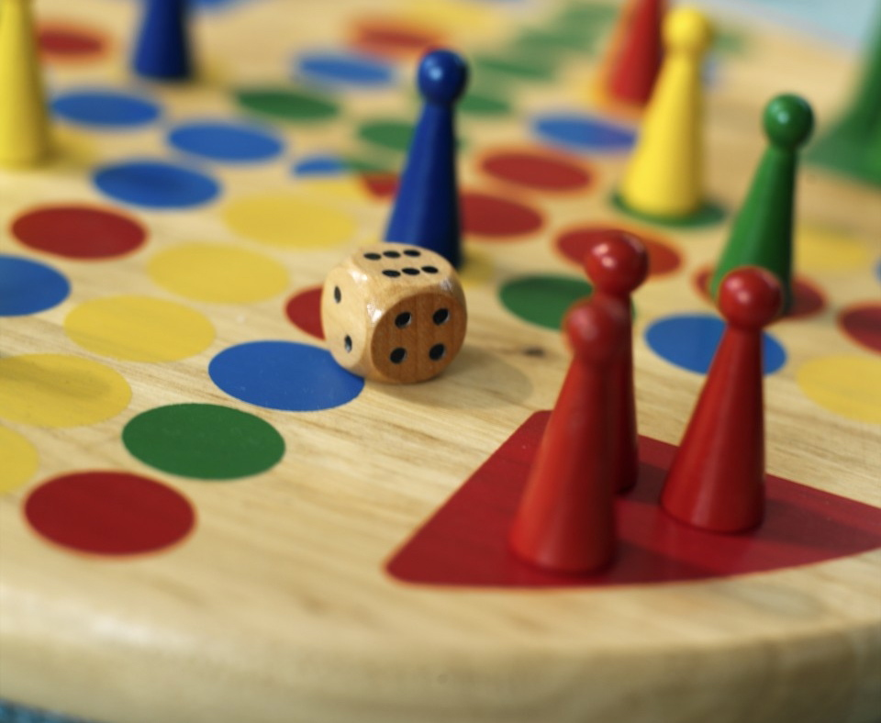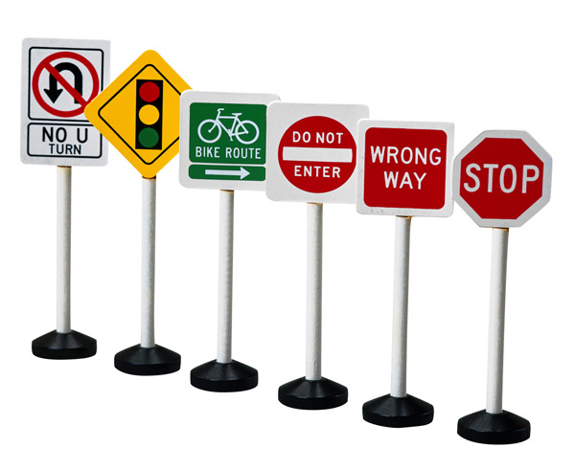4 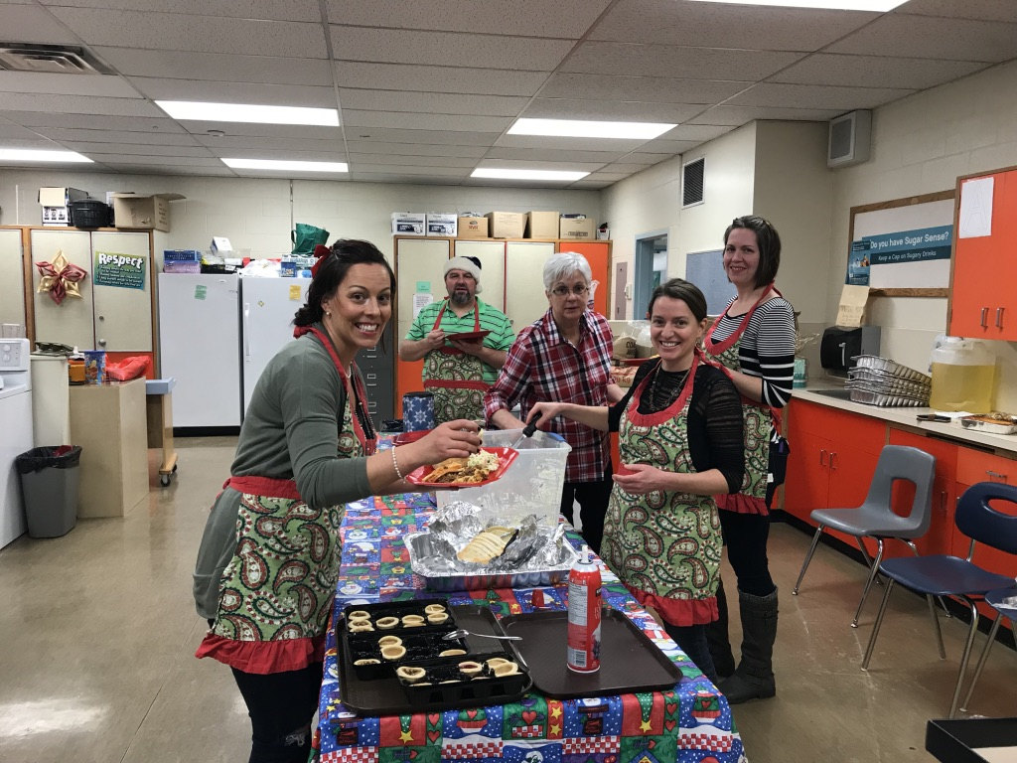

**47632 Old Boston Bar Road**

**Boston Bar, BC V0K 1C0**

**604.867.9222**

**604.867.8855 FAX**

<http://bostonbarschool.weebly.com/linksmedia.html>​

Staff:

Lisa Oike, Principal, 10-12 Math, Student Support

Renee Aldridge, Secretary

Glynis Fraser, Teacher K-3

Greg Mills, Teacher 4-6 Math/Sc, 9-12 Career Ed

Amanda Weber, Teacher 4-6 Eng/Soc/Fr, 7-12 Soc/Fr/Law/Tech

Michele Dekok, Teacher 7-9, 9-12 ADST

Sarah Laxton, Teacher 10-12, 7-9 Sc/Academic Support

Lillian Campbell, FNSW

Tara-Lynn Gray, SEA

Melissa Cummings, SEA/Lunch Hour Supervisor

Amanda Westerlund, StrongStart

Bus Supervisor

Gary Poole, Bus & Maintenance

Ang Hunter, Custodian/Choir

Patty Thomas, Custodian

Tom Willey, Shop Program

Counselor Support:

Kari Larson, HATS Mentor

Jessie Morris, SD 78 Counsellor

Judy Giroux, Speech Therapist

Melissa Nielson, FN Therapist

Megan Bissky, CYMH

Lydia Anderson, CYMH

## Boston Bar Elementary Secondary School

***Please sign below and present to your homeroom teacher.***

**I, ______________________ have read this handbook or had someone read it to me. I understand and agree to follow the expectations laid out within this BBESS Student Handbook.**

**__________________________**

**Student Signature**

**______________________ Parent Signature**

**Letter Grade** **Percentage** **The student demonstrates……….in relation**

**to expected learning outcomes for the**

**course or subject and grade.**

**A** 86-100% Excellent or Outstanding performance

**B** 73-85% Very Good performance

**C+** 67-72% Good performance

**C** 60-66% Satisfactory performance

**C-** 50-59% Minimally Acceptable performance

*NOTE: Successful Completion for numbered courses 10,11,*

*and 12 Requires a Minimum of a C- Grade*

**F** 0-49% Failing. Has not demonstrated the

Minimally acceptable performance

*NOTE: Grade. “F” may only be used as a final Grade if an “I” has been previously assigned.*

**I** In Progress Incomplete performance

*NOTE: Additional time is required to meet the expected learning*

*Outcomes for the course or subject and grade*.

W Withdrew A student withdrew from the course.

SG Standing Granted Although completion of normal requirements is

not possible, a sufficient level of performance

has bee attained.

My Academic Goals for the Year are:

1. ____________________________
2. ____________________________
3. ____________________________

My Homeroom Teacher is: ________________

My Courage Goals for the Year are:

1. ____________________________
2. ____________________________
3. ____________________________

Other Staff that will help me: __________________________________________

__________________________________________

Student Signature: ________________________

## Academic Achievement

2020-2021

7

Using the Culture of Courage and Respect Medicine Wheel the BBESS students and staff will encompass the four themes to guide our learning and create a healthy and respectful school climate. Each term we will celebrate students who promote and role model positive behaviors based on one of the themes. In the first term our focus will be Belonging, in the second term Generosity, in the third term Independence and the fourth term Mastery.

This Culture of Courage and Respect benefits all students, whether they are Aboriginal or Non Aboriginal students. It is an approach to promote positive peer support and creating an environment in which students feel supported, heard and valued. Each week students are rewarded with Courage Cards for their exemplary behavior. Weekly, term and year end draws acknowledge Courage Card Winners. Parents, family and friends are invited to attend our term end award assemblies to view the courage cards on display and celebrate the positive growth and success of our students.

**Culture**

**Of**

**Courage**

**& Respect**

## Postive BEHAVIOR PROGRAM

**Fraser-Cascade School District 78 Vision**

* Everyone Pulling Together to Improve the Achievement of all Learners
* All Learners Crossing the Stage with Dignity, Purpose and Options
* All Learners Leaving Our Settings more curious than When They Arrived
* All Learners Gaining an Understanding of, and Respect for, Indigenous Ways of Knowing

**Boston Bar Elementary Secondary Mission Statement**

Our school is committed to providing a caring and supportive learning environment that enables all students to achieve their individual potential. In a world where available information is growing exponentially, we believe that the most important thing a student needs to know is **how** to learn, and understanding that:

1. Learning is an active changing process that grows out of the interests and goals of each student.
2. Curriculum must be relevant to people and places that exist in our local community and in the real world.
3. Student learning must be authentically measured by the quality of their work in relation to specifically stated learning outcomes.

## Mission Statement

We strive to create a safe and respectful learning environment at BBESS. We consider the following acts to be serious breaches of the Code of Conduct, School Board Polices and/or the Criminal Code of Canada. Students who commit these acts will face severe disciplinary actions including suspensions or expulsions. Please be advised that as a matter of policy (SB Policy 7400), the RCMP will be notified of any illegal activities and may choose to conduct their own investigation.

1. The use, involvement with or possession of drugs alcohol or intoxicants. This includes being in possession of illegal drugs or alcohol, selling prohibited substances, being under the influence of drugs, alcohol or under suspicion of using drugs, alcohol or intoxicants by association, smell or behavior.
2. Theft, fighting, assault, vandalism or other acts that threaten the safety of staff and/or students and their property.
3. Possession or use of a weapon on or near school grounds during or after school hours including during any school sponsored activity off school grounds. Please not that SD 78 defines a weapon as:
   1. Anything that is used, can be used or is designed to put someone in fear; or
   2. Anything used or intended for use in causing death or injury to persons whether designed for that purpose or not; or
   3. Anything used, or intended for use, to threaten or intimidate any persona and, without restricting the generality of the forgoing, includes any replica weapon or firearm as defined in section 4 of the Criminal Code.
4. Repeated interference/disturbance of the learning process.
5. Physical or verbal intimidation or harassment of another student or staff member.
6. Outright defiance of a staff member.
7. Violation of fire or safety regulations.
8. Continual failure to apply oneself to one’s studies.

## Expectations, Rules & Policies

## attendance

## Visitors to School

All students are expected to attend regularly, and to be on time for classes. School is a priority and we expect that students will make every effort to schedule personal appointments outside of class hours. However, if a student is to be absent, arrive late, or is leaving early, then we request a phone call from a parent or guardian. If a student is absent and we have not received a call from a parent/guardian, then the parent/guardian will be informed of the absence.

**If students leave the building or arrive late, for any reason, they are expected to sign in/out.**

In all absences, it is the responsibility of the student to make contact with his/her teachers and make arrangements to complete any missed work, projects, quizzes or tests.

For elementary students, please check with your child’s teacher for work that will be missed.

To ensure the safely of our students and staff, **ALL VISITORS** (including parents, student’s friends and community members), **must report to the office and SIGN IN upon entry into the school. Student visitors MUST get permission from classroom teacher and Principal Prior to Visit. NO EXCEPTIONS**



## Dress Code

We believe in a progressive discipline process, which provides a student an opportunity to be warned and to correct their behavior. A Four (4) Level Program will provide opportunities for a student to correct behavior and get back on track. If the student progresses through the four levels quickly or their behavior elevates they will be sent to the office without going through all four levels.

**Levels of Action**

**Level Teacher Student Parent**

**Action Action Contacted**

1 1st Warning Self Manages No

2 2nd Warning Sits quiet area in classroom No

3 3rd Warning Buddy Room No

*After a period of time the student will return to his/her classroom*

*based on the Buddy teacher’s discretion.*

4 4th Warning See the Principal Yes

The Teacher can “State” the levels out loud or simply develop eye contact with the student and put up the corresponding number of fingers to direct the student without interrupting instruction. On Level 3 the teacher may or may not call the parent depending on the frequency of the infraction.

Each day is a fresh start and a student starts over at zero (o) level. However, if the student’s behavior persists frequently a Parent, Teacher, Counselor and Principal meeting will be held to create a Student Success Plan.

**Level 4 is progressive** in discipline. Students do not receive a “fresh start”. Discipline will start with time out, lunch detention, loss of privileges, In School Suspension, Out of School Suspension and a possible Expulsion.

## Discipline Process

The students, staff and parents of BBESS are the partnership groups responsible for developing and implementing this dress code.   It has been set to help eliminate peer pressure related to student attire and to create a learning environment that is comfortable for all.  Students, staff, parents and visitors to the school are to be advised of the following regulations and are expected to adhere to the code.

1. Clothing that references any of the following is not permitted at school or at school sponsored events:

* + Alcohol, drugs or tobacco
  + Derogatory, racial, anti-religious statements
  + Messages of a sexual or sexist nature
  + Vulgar, abusive and inappropriate language.
  + Any illegal activity or gang references

2. Clothing must cover the entire back, front and mid-section at all times. (Halter-tops, backless shirts, bare midriffs and transparent clothing are not acceptable.)

* 3. Dresses (slits in dresses,) skirts and shorts must be no shorter than mid-thigh.
* 4. Undergarments, worn by males or females, are not to be visible at any time. (Bra-straps under spaghetti strap tops are an exception). Low-rise jeans must cover undergarments.
* 5. Sunglasses will not be worn at any time inside the building unless there is a medical reason supported by a physician’s note.
* 6. Hats will be removed in the gym for all assemblies.  (In classrooms, including the shop and gym, hats may or may not be worn at the individual teacher’s discretion.)
* 7. Due to allergies any outer garment or clothing smelling of smoke or heavy cologne should be turned over to the principal and will be returned to the student at the end of the day.

We see technology as an integral part of each student’s education and we are working to include technology into each classroom curriculum. Each student has a right to use electronic devices for educational purposes while in our building. Students also have the right to be part of an Internet community FREE from hate or bullying. The rules for technology include:

* Students working on computers or tablets must have direct teacher supervision.
* Students should have user names and passwords to access school technology.
* Students and their parents will be asked to sign a Parent/Guardian Social Media Usage Contract and Student Technology Acceptable Use Agreement
* Students will maintain the same standards of behavior and communication in the classroom when using online learning resources. All School rules apply.
* Students will not reveal personal information when using the Internet.
* Students MAY NOT DOWNLOAD or INSTALL any software programs onto school computers/tablets.
* Students will participate responsibly and refrain from accessing resources not selected or approved by teachers. Students will exit any inappropriate resources accidentally accessed and then inform a staff member.
* Our Internet access is for educational purposes only.
* Students are encouraged to bring electronic devices to school for educational purposes. However, the school **is not responsible for any lost or damaged personal electronic device.** Students will not access school Wi-Fi on individual devices.
* Devices must be displayed on desk or table during instructional time. Three violations will result in the removal of the device and loss of privilege to carry the device at school.

## Technology: Computers & electronic devices

## Bad Weather and “in-days”

The Board of School Trustees has approved policies and regulations that ensure your right to appeal decisions made at the school. Policies are available through the school or school board office. To make an appeal, the following steps should be followed:

1. Your first step in any appeal is to go to the individual (or group) directly responsible for the decision. For example, if you disagree with something the classroom teacher has decided, the next step is to go to the teacher. If you disagree with something the Principal has done, then go to the principal.
2. If you are unsatisfied with the outcome of step one, then go to that person’s supervisor. If it is a teacher, then you go to the principal. If it is the Principal, then you should go to the Superintendent.

The school doors open and supervision begins at 8:10 am. There is no guarantee of supervision prior to 8:10 am. **We cannot accept liability for accidents and other incidents occurring if your child comes before supervision begins.**

Elementary students are expected to go outside during the morning recess and lunchtime periods. Please ensure that your child wears clothing appropriate to weather conditions so they can be comfortable during those breaks. Limited extra winter gear is available at the school. Please contact your child’s teacher if you have any questions. Layered clothing is best to provide your child with options throughout the day.

## District Appeal Procedure

The School Act specifically designates a school’s Parent Advisory Council as the parents’ “Official Voice” to the school staff and the School Board. All parents belong to this council. We encourage you to become involved with your PAC and to attend meetings on the first Tuesday of each month. Contact the PAC President, Shoneena Loss-Walters if you wish to receive monthly copies of meeting minutes.

We provide special programs for Special Education students in the areas of academic support, program adjustments and behavioral modification. These programs may take the form of assisting teachers in finding appropriate support materials, diagnosing problem areas, prescribing types of programs, involving outside clinicians such as school psychologists, speech pathologists, or reading specialists, or gathering information to assist parents and teachers in decision on placement of students in programs.

Student are required to bring a healthy lunch and snack to school on a daily basis.

Together with PAC and SEA support, a Monday lunch/ breakfast program will be created and regularly scheduled meals will be made available for students. Times and dates of these meals will be sent home in note format, posted on Facebook and on the school Website.

## office hours

## Newsletters

Homework is a necessary portion of your child’s education. Each teacher and classroom has different requirements for homework. Teachers will communicate with students their expectations. At the most basic level we ask all parents to be involved in their student’s education by checking their agenda, backpacks or questioning them. For other ways to support your child’s learning, please contact homeroom/course teachers. We are partners in your child’s education and the more we work together, the more successful your child will be.

Communication between the school and home is key to our success. Monthly articles in the UPDATE and newsletters supplemented by the BBESS School Facebook Group will be sent out periodically. If you think you are missing information please contact the office or view the school web page. If you or a family member have special news to share, please contact the office so we can incorporate your news.

The school office hours are normally from 8:00 am – 12:00 and 1:00 pm to 4:00 pm on all instructional days from September to June. Depending on planned activities, it may not always be open during non-instructional days. The office phone is equipped with an answering machine if you need to leave a message outside of regular office hours.

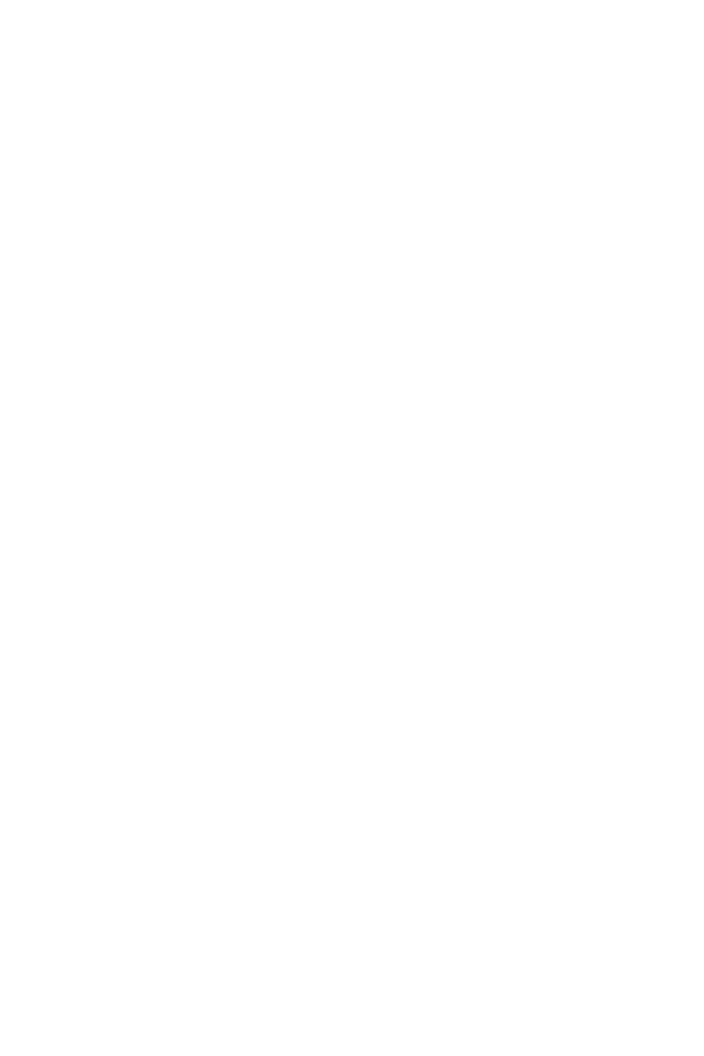

## lunches and snacks

## Special services

## Parent advisory council (PAC)

## Homework

## School pictures

## Accidents, injuries and illnesses at school

## Absences & special activities

Throughout the year there are many occasions when the school provides and supports extracurricular experiences for students. These may include special performances, sports events, movies, gym activities, fieldtrips, school dances, etc. These opportunities are an excellent way to motivate students as well as providing curricular extension. We look upon access to these occasions as some that students “earn” through cooperation, good behavior and hard work. Therefore, it is a privilege to be allowed access to these events, and undeserving students may be excluded or particular events may be cancelled, depending on the circumstances.

Except in special circumstances, students must be in attendance on the day of a practice, trip, dance or other activity to participate in that activity. If in doubt, consult the Principal. Permission forms for special events must be signed and returned at least the day before the trip or event are student will not be allowed to attend. No exceptions and No phone permissions will be accepted.

When accidents involve injuries occurring on school grounds or within the school building, they must be reported to the office as soon as possible so we can start treatment. After any such incident, an official Incident Report Form will be filled out detailing what happened and what action was taken. If necessary, you will be contacted to let you know of your child’s situation and possible picking them up. If we cannot get in contact with you or your emergency contact, we reserve the right to call an ambulance. We will always err on the side of “better safe than sorry”. We are not a medical facility and cannot treat injuries that occur away from school grounds.

## Special activities

All students are expected to participate fully in their physical education program unless medically or otherwise unable. If you feel your child cannot participate in part or all of his/her PE class send their teacher a note stating what he/she may or may not do.

All students are required to wear proper non-marking fully laced footwear for gym class for the protection of the gym floor and to provide traction for active students. Primary students use indoor shoes for gym class. Intermediate and High School students are required to bring a separate set of clothes for gym. These clothes should include a gym shirt, shorts or sweats that allow free and comfortable movement and play. Students are encouraged to practice good hygiene and bring deodorant products to maintain this. Please remember we are a scent free building and use only unscented products. **Do not bring perfumes/body spray to school.**

School District 78 provides Counselor and Student Support Services. As well as First Nation’s Counselor services and First Nation’s Aboriginal Mentor available to provide social-emotional support during weekly visits to BBESS.

If you feel that your child will benefit from seeing a counselor, please contact us and we will provide you with permission forms necessary to receive services.

Our school signs an annual contract with a photography company to have individual, class and whole-school pictures taken. It is expected that all children will get their picture taken, although any purchase of pictures is completely optional. The individual pictures are normally taken early in the fall, while the class and whole school are taken in the spring.

## social emotional support

## Physical and Health Education

***Statement of Purpose***

The Boston Bar Elementary Secondary School Code of Conduct will help establish and maintain a safe, caring and orderly environment at school while clarifying expectations for student behaviour. We wish to provide all individuals the best opportunities for positive social development, purposeful learning and experiencing success.

***Conduct Expectations***

Boston Bar Elementary Secondary School promotes the values expressed in the ***BC Human Rights Code*** respecting the right of all individuals in accordance with the law. This includes prohibiting discrimination based on race, colour, ancestry, place of origin, religion, marital status, family status, physical or mental disability, sex, sexual orientation, gender identity or expression, and age.

All students will be expected to promote respect, responsibility and safety while at school, while going to and from school and while attending school functions or activities at alternate locations. Unacceptable behaviour includes interfering with the learning of self-and/or others, creating unsafe conditions, swearing, wearing inappropriate clothing, smoking including e-cigarettes and other smoking devices, acts of bullying, cyberbullying, harassment, intimidation, discrimination any kind, threatening or violent behaviour, and theft and/or damage of property. The Code of Conduct also applies to any instance where the safe and orderly operation of the school is threatened and/or welfare of the students or staff may be affected.

***Consequences***

Responses to poor behaviour choices are **consistent** and **fair** for each student. Behavioural expectations rise as students’ progress through Kindergarten to grade 12 and will consider all students with special needs and disabilities of an intellectual, physical, sensory, emotional and behavioural nature. Disciplinary action, whenever possible, is restorative and will include a learning task. Our goal is to work on positively reframing behaviours by spending time outside of class (recess, lunch and after school) researching, studying and writing about good choices and appropriate behaviours. At times, more focused disciplinary processes must occur especially with more serious misbehaviours or repeated minor behaviours. These decisions will be made by the principal and may include behaviour plans developed by the School Based Team and/or within meetings with parents/caregivers. In-school and out-of-school suspension will occur only in extreme circumstances such as acts of violence towards students or staff.

***Process***

At our school, introducing, modelling and reinforcing positive social behaviour is an important goal to improve our students educational experience. Teaching behavioural expectations and rewarding students for following them is a much more positive approach. Thus, any consequences for inappropriate behaviour will occur in a manner that the dignity and self-esteem of the individual is maintained, and the well-being of any person who is harmed is restored. Emphasis is directed towards developing and maintaining learning environments where teachers can teach and all students can learn.

At Boston Bar Elementary Secondary School, teachers and students follow the positive traits provided for all areas in our school through our Code of Conduct Chart. Each family will have a copy of the chart to review at home and it is also found in every classroom and on our website. Families are encouraged to help the staff of BBESS to enforce acceptable, appropriate behaviours. If we work as a team we can ensure our learners are successfully moving towards learning that provides dignity, pride, purpose and options.

***Family Involvement***

The staff of Boston Bar Elementary Secondary School promotes the involvement of all parents and/or caregivers in their child’s education and in improving the school. When families are involved, students exhibit more positive attitudes and behaviours. Feeling supported both at home and at school, students have more self-confidence, feel school is more important, tend to perform better in classes and show a decrease in at-risk behaviours.

At school students will be rewarded with ***Courage Cards*** from teachers and staff members who witness behaviours that display one or more of the term themes from the Courage and Respect Medicine Wheel: Belonging, Generosity, Independence and Mastery. In Addition, we will be honouring ***Academic/Skills/Behavioural Excellence*** at term end, in each grade level. Families can guide and support their child’s learning by ensuring that he/she:

1) **Attends** school daily and arrives **on time**, ready for the day’s learning experience

2) **Completes** all homework assignments given by teachers

3) **Reads** daily to develop a love for reading and to improve literacy skills

4) **Shares** school experiences with you so that you are aware of his/her school life

5) **Informs** you if he/she needs additional support in any area or subject

6) **Knows** that you expect him/her to succeed in school and be postsecondary ready

Boston Bar Elementary Secondary School will also work within the guidelines of the following district policies that are related to student conduct:

 •  Policy #7007 – Student Conduct

 •  Policy #7008 – Student Threat Assessment

 •  Policy #7009 – Damage or Destruction of School Property

 •  Policy #7030 – Physical Restraint of Students

 •  Policy #7200 – Student Suspensions

 •  Policy #7340 – Allergies and Life-Threatening Allergies in School

 •  Policy #7400 – Student Involvement with Alcohol, Intoxicants, and Illegal Drugs

 •  Policy #7420 – Weapons, Violence, and Intimidation

 •  Policy #7430 – Student Dress Code

 •  Policy #7700 – Student Transportation

***All School District No.78 policies can be viewed at:***[***SD78 Policies***](http://www.sd78.bc.ca/policymanual.html)

## BBESS Code of Conduct

## scent free

Except in special situations, staff members do not generally administer medication to students. In no instance will staff administer medication from a source other than the parent, with the parent’s permission. Students are not allowed to give one another medication. If your child is required to take any medication at school, please contact the office to make arrangements.

If your child is in need of an Epi-Pen please ensure that the school has one in the health office or with your child. For your child’s safety a school needs to know where it is located so that we can administer immediately.

We collect personal student and family information under the authority of the School Act, Sections 13 & 97 and/or Ministerial Order M152/89. This information is used for educational program purposes only, and when required may be provided to health services, social services, or other support services as outlined in Section 07(2) of the School Act and/or the information will be used for data submission to the Ministry of Education. The information collected is protected under the federal Freedom of Information and Protection and Privacy Act (FOIPPA). Questions about the collection and use of any such information should be directed to the Principal of the school and/or the Secretary-Treasurer of the school district.

Our school building is designated as a scent free zone under district policy. We have both staff and students that suffer from asthma that can be triggered by strong scents. Students should never bring perfumes or body sprays into the building. Any of these substances found in the building will be confiscated for the safety of our students and staff.

## Personal Information/foippa

## Adminstration of medication